|  |
| --- |
|  |
| **PROJECT** |
| **Library Management System** |
|  |



Name : Ritesh Tiwari

Course : CCPA

Roll : P03201818C

Batch : P03/2018

Project Topic : Library Management System

**Software use**:

Visual Basic 2010, MS Access, Windows 10

**Hardware use**:

CD, Printer, Monitor,

Keyboard, Mouse

**Language use**:

C Sharp (C#)

CONTENTS

*ADMIN LOG IN PAGE 4*

*ADMIN ID 6*

*ADD NEW BOOK MENU 8*

*BOOKS INFORMATION MENU 10*

*ADD NEW USER ID MENU 13*

*USERS INFORMATION MENU 16*

*BOOKKS ISSUE MENU 19*

*CRYSTAL REPORT 21*

*USER LOG IN 22*

*USER ID MENU 22*

## ADMIN LOG IN PAGE

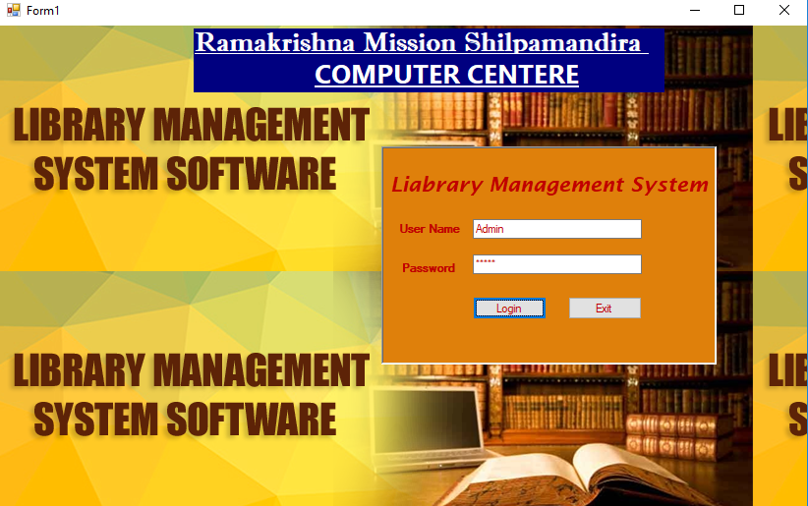

using System;

using System.Collections.Generic;

using System.ComponentModel;

using System.Data;

using System.Drawing;

using System.Linq;

using System.Text;

using System.Windows.Forms;

namespace LMS

{

public partial class Form1 : Form

{

public Form1()

{

InitializeComponent();

}

private void button1_Click_1(object sender, EventArgs e)

{

if (this.textBox1.Text.Trim() == "" && this.textBox2.Text.Trim() == "")

{

MessageBox.Show("Enter User Name and Password !");

}

else if (this.textBox1.Text.Trim() == "Admin" && this.textBox2.Text.Trim() == "Admin")

{

Main frm = new Main();

frm.Show();

}

else if (this.textBox2.Text.Trim() == "2001" && this.textBox1.Text.Trim() == "Ritesh")

{

Issue iss = new Issue();

iss.Show();

}

else

MessageBox.Show("User Name And Password wrong...........");

}

private void button2_Click_1(object sender, EventArgs e)

{

Close();

}

}

}

## ADMIN ID

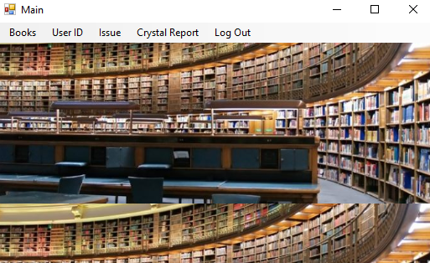

using System.Windows.Forms;

namespace LMS

{

public partial class Main : Form

{

public Main()

{

InitializeComponent();

}

private void logOutToolStripMenuItem_Click(object sender, EventArgs e)

{

Close();

Form1 frm = new Form1();

frm.Show();

}

private void viewUpdateToolStripMenuItem_Click(object sender, EventArgs e)

{

Add_Books ab = new Add_Books();

ab.Show();

}

private void addIDToolStripMenuItem_Click(object sender, EventArgs e)

{

User_ID id=new User_ID();

id.Show();

}

private void viewUpdateToolStripMenuItem1_Click(object sender, EventArgs e)

{

View_Books vb = new View_Books();

vb.Show();

}

private void viewAndUpdateIDToolStripMenuItem_Click(object sender, EventArgs e)

{

User_info uinfo = new User_info();

uinfo.Show();

}

private void issueToolStripMenuItem_Click(object sender, EventArgs e)

{

}

private void issueBooksToolStripMenuItem_Click(object sender, EventArgs e)

{

Issue_book pbook = new Issue_book();

pbook.Show();

}

private void reportToolStripMenuItem_Click(object sender, EventArgs e)

{

Report rp = new Report();

rp.Show();

}

private void Main_Load(object sender, EventArgs e)

{

}

}

}

## ADD NEW BOOK MENU

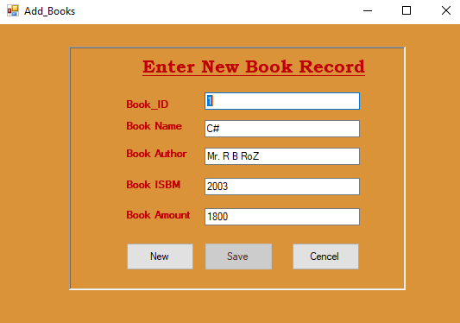

using System.Data.OleDb;

namespace LMS

{

public partial class Add_Books : Form

{

OleDbConnection con = new OleDbConnection();

OleDbCommand com;

OleDbDataAdapter da;

DataSet ds;

int i = -1;

public Add_Books()

{

InitializeComponent();

}

private void Add_Books_Load(object sender, EventArgs e)

{

this.savebtn.Enabled = false;

con.ConnectionString = "Provider=Microsoft.Jet.OLEDB.4.0;Data Source=D:\\Ritesh\\LMS\\Books.mdb";

con.Open();

com = new OleDbCommand("Select *from Table1", con);

da = new OleDbDataAdapter(com);

ds=new DataSet();

da.Fill(ds);

if (ds.Tables[0].Rows.Count > 0)

{

this.textBox1.Text = ds.Tables[0].Rows[0][0].ToString();

this.textBox2.Text = ds.Tables[0].Rows[0][1].ToString();

this.textBox3.Text = ds.Tables[0].Rows[0][2].ToString();

this.textBox4.Text = ds.Tables[0].Rows[0][3].ToString();

this.textBox5.Text = ds.Tables[0].Rows[0][4].ToString();

i = 0;

}

con.Close();

}

private void cancelbtn_Click(object sender, EventArgs e)

{

Close();

}

private void Newbtn_Click(object sender, EventArgs e)

{

this.textBox1.Text = "";

this.textBox2.Text = "";

this.textBox3.Text = "";

this.textBox4.Text = "";

this.textBox5.Text = "";

this.savebtn.Enabled = true;

this.Newbtn.Enabled = false;

}

private void savebtn_Click(object sender, EventArgs e)

{

con.ConnectionString = "Provider=Microsoft.Jet.OLEDB.4.0;Data Source=D:\\Ritesh\\LMS\\Books.mdb";

con.Open();

string sql;

sql="insert into Table1 values("+Convert.ToInt16(this.textBox1.Text)+",'"+this.textBox2.Text+"','"+this.textBox3.Text+"',"+Convert.ToInt32(this.textBox4.Text)+","+Convert.ToInt32(this.textBox5.Text)+")";

MessageBox.Show(sql);

com = new OleDbCommand(sql,con);

com.ExecuteNonQuery();

con.Close();

this.Newbtn.Enabled = true;

i=ds.Tables[0].Rows.Count-1;

}

}

}

## BOOKS INFORMATION MENU

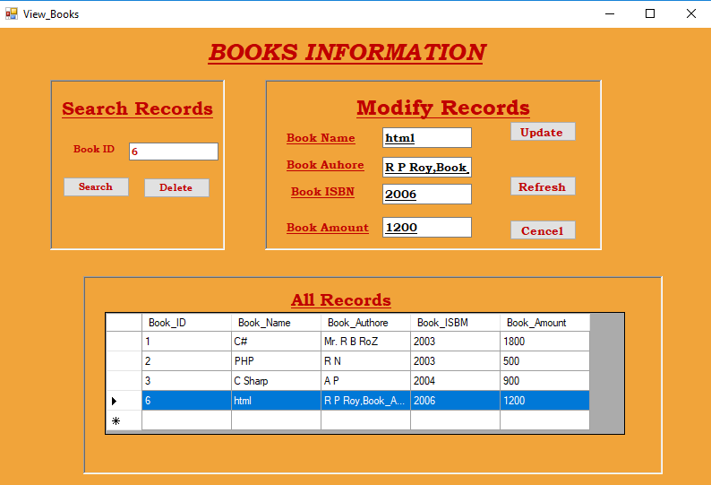

using System.Data.OleDb;

namespace LMS

{

public partial class View_Books : Form

{

OleDbConnection con = new OleDbConnection();

OleDbCommand com;

OleDbDataAdapter da;

DataSet ds;

public View_Books()

{

InitializeComponent();

}

private void View_Books_Load(object sender, EventArgs e)

{

con.ConnectionString = "Provider=Microsoft.Jet.OLEDB.4.0;Data Source=D:\\Ritesh\\LMS\\Books.mdb";

con.Open();

com = new OleDbCommand("select *from Table1", con);

da = new OleDbDataAdapter(com);

ds = new DataSet("r1");

da.Fill(ds, "r1");

this.dataGridView1.DataSource = ds;

this.dataGridView1.DataMember = "r1";

con.Close();

}

private void DeleteBtn_Click_1(object sender, EventArgs e)

{

con.ConnectionString = "Provider=Microsoft.Jet.OLEDB.4.0;Data Source=D:\\Ritesh\\LMS\\Books.mdb";

con.Open();

string sql;

sql = "delete from Table1 where Book_ID=" + Convert.ToInt32(this.textBox1.Text);

MessageBox.Show(sql);

com = new OleDbCommand(sql, con);

com.ExecuteNonQuery();

con.Close();

View_Books_Load(sender, e);

}

private void UpdateBTn_Click(object sender, EventArgs e)

{

con.ConnectionString = "Provider=Microsoft.Jet.OLEDB.4.0;Data Source=D:\\Ritesh\\LMS\\Books.mdb";

con.Open();

string sql;

sql ="update Table1 set Book_Name='" +this.textBox2.Text+"', Book_Authore='"+this.textBox3.Text+"',Book_ISBM='"+this.textBox4.Text+"',Book_Amount="+Convert.ToInt32(this.textBox5.Text)+" where Book_ID="+Convert.ToInt32(textBox1.Text);

MessageBox.Show(sql);

com = new OleDbCommand(sql, con);

com.ExecuteNonQuery();

con.Close();

View_Books_Load(sender, e);

}

private void CencelBtn_Click_1(object sender, EventArgs e)

{

Close();

}

private void RefreshBtn_Click(object sender, EventArgs e)

{

View_Books_Load(sender, e);

}

private void panel2_Paint(object sender, PaintEventArgs e)

{

}

private void SearchBTn_Click(object sender, EventArgs e)

{

con.ConnectionString = "Provider=Microsoft.Jet.OLEDB.4.0;Data Source=D:\\Ritesh\\LMS\\Books.mdb";

con.Open();

com = new OleDbCommand("select * from Table1 where Book_ID=" + Convert.ToInt32(this.textBox1.Text), con);

da = new OleDbDataAdapter(com);

ds = new DataSet();

da.Fill(ds);

if (ds.Tables[0].Rows.Count > 0)

{

this.textBox1.Text = ds.Tables[0].Rows[0][0].ToString();

this.textBox2.Text = ds.Tables[0].Rows[0][1].ToString();

this.textBox3.Text = ds.Tables[0].Rows[0][2].ToString();

this.textBox4.Text = ds.Tables[0].Rows[0][3].ToString();

this.textBox5.Text = ds.Tables[0].Rows[0][4].ToString();

}

else

MessageBox.Show("Record not found");

con.Close();

}

}

}

## ADD NEW USER ID MENU

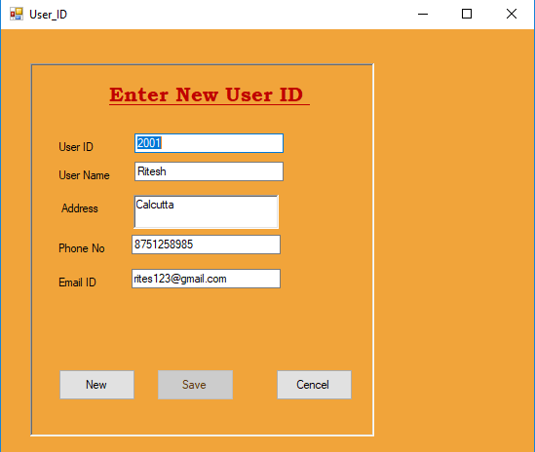

using System.Data.OleDb;

namespace LMS

{

public partial class User_ID : Form

{

OleDbConnection con = new OleDbConnection();

OleDbCommand com;

OleDbDataAdapter da;

DataSet ds;

int i = -1;

public User_ID()

{

InitializeComponent();

}

private void Newbtn_Click(object sender, EventArgs e)

{

this.textBox1.Text = "";

this.textBox2.Text = "";

this.richTextBox1 .Text = "";

this.textBox4.Text = "";

this.textBox5.Text = "";

this.savebtn.Enabled = true;

this.Newbtn.Enabled = false;

}

private void User_ID_Load(object sender, EventArgs e)

{

this.savebtn.Enabled=false;

con.ConnectionString="Provider=Microsoft.Jet.OLEDB.4.0;Data Source=D:\\Ritesh\\LMS\\UserID.mdb";

con.Open();

com=new OleDbCommand("Select *from Table3",con);

da=new OleDbDataAdapter(com);

ds=new DataSet();

da.Fill(ds);

if(ds.Tables[0].Rows.Count>0)

{

this.textBox1.Text=ds.Tables[0].Rows[0][0].ToString();

this.textBox2.Text=ds.Tables[0].Rows[0][1].ToString();

this.richTextBox1 .Text=ds.Tables[0].Rows[0][2].ToString();

this.textBox4.Text =ds.Tables[0].Rows[0][3].ToString();

this.textBox5.Text =ds.Tables[0].Rows[0][4].ToString();

i=0;

}

con.Close();

}

private void cancelbtn_Click(object sender, EventArgs e)

{

Close();

}

private void savebtn_Click(object sender, EventArgs e)

{

con.ConnectionString = "Provider=Microsoft.Jet.OLEDB.4.0;Data Source=D:\\Ritesh\\LMS\\UserID.mdb";

con.Open();

string sql;

sql = "insert into Table3 values(" + Convert.ToInt32(this.textBox1.Text) + ",'" + this.textBox2.Text + "','" + this.richTextBox1.Text + "'," + Convert.ToInt32(this.textBox4.Text) + ",'" +this.textBox5.Text + "')";

MessageBox.Show(sql);

com = new OleDbCommand(sql, con);

com.ExecuteNonQuery();

con.Close();

this.Newbtn.Enabled = true;

i = ds.Tables[0].Rows.Count - 1;

}

}

}

## 

## USERS INFORMATION MENU

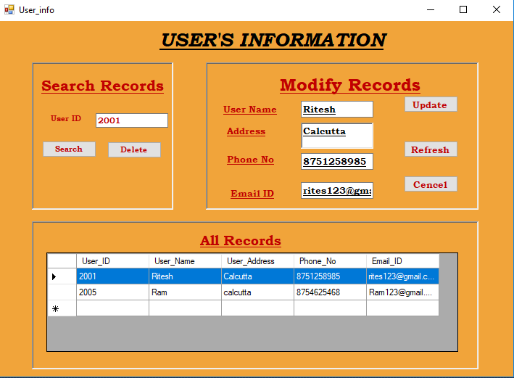

using System.Data.OleDb;

namespace LMS

{

public partial class User_info : Form

{

OleDbConnection con = new OleDbConnection();

OleDbCommand com;

OleDbDataAdapter da;

DataSet ds;

public User_info()

{

InitializeComponent();

}

private void User_info_Load(object sender, EventArgs e)

{

con.ConnectionString = "Provider=Microsoft.Jet.OLEDB.4.0;Data Source=D:\\Ritesh\\LMS\\UserID.mdb";

con.Open();

com = new OleDbCommand("select *from Table3", con);

da = new OleDbDataAdapter(com);

ds = new DataSet("r1");

da.Fill(ds, "r1");

this.dataGridView1.DataSource = ds;

this.dataGridView1.DataMember = "r1";

con.Close();

}

private void DeleteBtn_Click(object sender, EventArgs e)

{

con.ConnectionString = "Provider=Microsoft.Jet.OLEDB.4.0;Data Source=D:\\Ritesh\\LMS\\UserID.mdb";

con.Open();

string sql;

sql = "delete from Table3 Where User_ID=" + Convert.ToInt32(this.textBox1.Text);

MessageBox.Show(sql);

com = new OleDbCommand(sql, con);

com.ExecuteNonQuery();

con.Close();

User_info_Load(sender, e);

}

private void UpdateBTn_Click(object sender, EventArgs e)

{

con.ConnectionString = "Provider=Microsoft.Jet.OLEDB.4.0;Data Source=D:\\Ritesh\\LMS\\UserID.mdb";

con.Open();

string sql;

sql = "update Table3 set User_Name='" + this.textBox2.Text + "', User_Address='" + this.richTextBox1.Text + "',Phone_No='" +Convert.ToInt32( this.textBox4.Text) + "',Email_ID='" +Convert.ToInt32( this.textBox5.Text) + "' where User_ID=" +Convert.ToInt32( textBox1.Text );

MessageBox.Show(sql);

com = new OleDbCommand(sql, con);

com.ExecuteNonQuery();

con.Close();

User_info_Load (sender, e);

}

private void SearchBTn_Click(object sender, EventArgs e)

{

con.ConnectionString = "Provider=Microsoft.Jet.OLEDB.4.0;Data Source=D:\\Ritesh\\LMS\\UserID.mdb";

con.Open();

com = new OleDbCommand("select * from Table3 where User_ID='"+this.textBox1.Text+"'", con);

da = new OleDbDataAdapter(com);

ds = new DataSet();

da.Fill(ds);

if (ds.Tables[0].Rows.Count > 0)

{

this.textBox1.Text = ds.Tables[0].Rows[0][0].ToString();

this.textBox2.Text = ds.Tables[0].Rows[0][1].ToString();

this.richTextBox1.Text = ds.Tables[0].Rows[0][2].ToString();

this.textBox4.Text = ds.Tables[0].Rows[0][3].ToString();

this.textBox5.Text = ds.Tables[0].Rows[0][4].ToString();

}

else

MessageBox.Show("Record not found");

con.Close();

}

private void dataGridView1_CellContentClick(object sender, DataGridViewCellEventArgs e)

{

}

}

}

## 

## BOOKKS ISSUE MENU

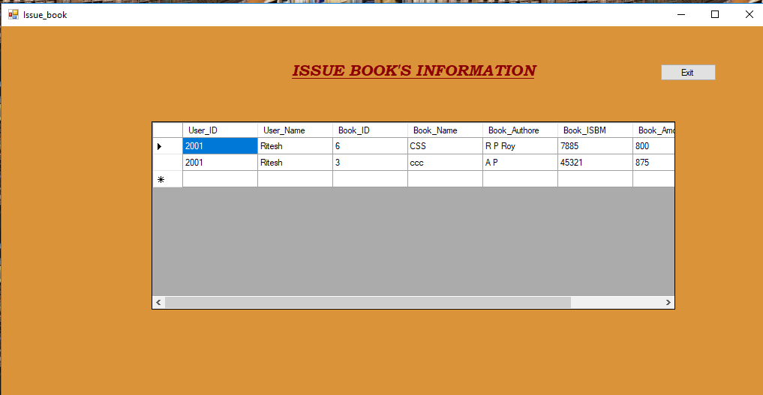

using System.Data.OleDb;

namespace LMS

{

public partial class Issue_book : Form

{

OleDbConnection con = new OleDbConnection();

OleDbCommand com;

OleDbDataAdapter da;

DataSet ds;

public Issue_book()

{

InitializeComponent();

}

private void Purchased_book_Load(object sender, EventArgs e)

{

con.ConnectionString = "Provider=Microsoft.Jet.OLEDB.4.0;Data Source=D:\\Ritesh\\LMS\\Issue.mdb";

con.Open();

com = new OleDbCommand("select *from Table2", con);

da = new OleDbDataAdapter(com);

ds = new DataSet("r1");

da.Fill(ds, "r1");

this.dataGridView1.DataSource = ds;

this.dataGridView1.DataMember = "r1";

con.Close();

}

private void button1_Click(object sender, EventArgs e)

{

Close();

Main mn = new Main();

mn.Show();

}

}

}

## CRYSTAL REPORT

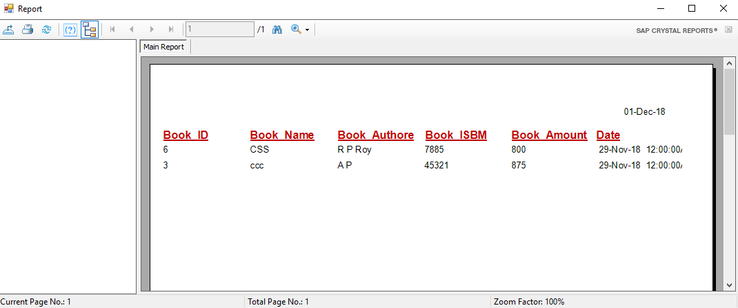

## USER LOG IN

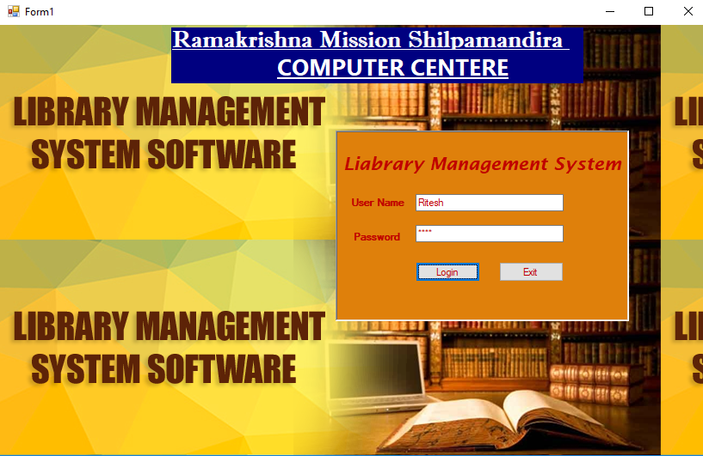

## USER ID MENU

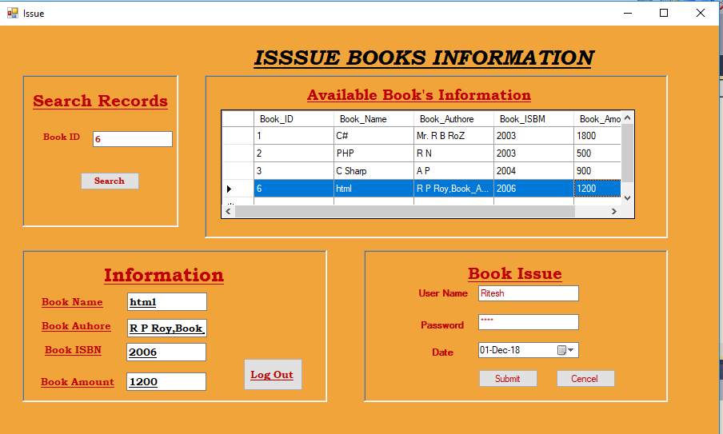

using System.Data.OleDb;

namespace LMS

{

public partial class Issue : Form

{

OleDbConnection con = new OleDbConnection();

OleDbCommand com;

OleDbDataAdapter da;

DataSet ds;

public Issue()

{

InitializeComponent();

}

private void Issue_Load(object sender, EventArgs e)

{

con.ConnectionString = "Provider=Microsoft.Jet.OLEDB.4.0;Data Source=D:\\Ritesh\\LMS\\Books.mdb";

con.Open();

com = new OleDbCommand("select *from Table1", con);

da = new OleDbDataAdapter(com);

ds = new DataSet("r1");

da.Fill(ds, "r1");

this.dataGridView1.DataSource = ds;

this.dataGridView1.DataMember = "r1";

con.Close();

}

private void SearchBTn_Click(object sender, EventArgs e)

{

con.ConnectionString = "Provider=Microsoft.Jet.OLEDB.4.0;Data Source=D:\\Ritesh\\LMS\\Books.mdb";

con.Open();

com = new OleDbCommand("select * from Table1 where Book_ID=" + Convert.ToInt32(this.textBox1.Text), con);

da = new OleDbDataAdapter(com);

ds = new DataSet();

da.Fill(ds);

if (ds.Tables[0].Rows.Count > 0)

{

this.textBox1.Text = ds.Tables[0].Rows[0][0].ToString();

this.textBox2.Text = ds.Tables[0].Rows[0][1].ToString();

this.textBox3.Text = ds.Tables[0].Rows[0][2].ToString();

this.textBox4.Text = ds.Tables[0].Rows[0][3].ToString();

this.textBox5.Text = ds.Tables[0].Rows[0][4].ToString();

}

else

MessageBox.Show("Record not found");

con.Close();

}

private void button1_Click(object sender, EventArgs e)

{

con.ConnectionString = "Provider=Microsoft.Jet.OLEDB.4.0;Data Source=D:\\Ritesh\\LMS\\Issue.mdb";

con.Open();

string sql;

sql = "insert into Table2 values('" +this.textBox6.Text+ "','" + this.textBox7.Text + "','" +Convert.ToInt32( this.textBox1.Text) + "','" + this.textBox2.Text + "','" + this.textBox3.Text + "','" + +Convert.ToInt32(this.textBox4.Text) + "','" + Convert.ToInt32(this.textBox5.Text)+"','"+ this.dateTimePicker1.Text+"')";

MessageBox.Show(sql);

com = new OleDbCommand(sql, con);

com.ExecuteNonQuery();

con.Close();

}

private void button3_Click(object sender, EventArgs e)

{

Close();

Form1 frm = new Form1();

frm.Show();

}

}

}